Legal name: ___________________________________________________________
Preferred name: ________________________
Date of Birth: ____________________ Patient SSN: _______________________
Mailing address: ____________________________________________________
City: ________________ ST __________ Zip ____________
Legal Gender: □Female □Male
Preferred Provider: □Ann Gwinnup, MD □Rachel L. White, APRN
CONTACT INFORMATION:
Primary phone: (____) ____________ Alternative phone: (____) _____________
Email: _____________________________________
DO YOU CONSENT TO RECEIVE TEXT MESSAGES: □ YES □ NO
HOW DO YOU PREFER TO BE CONTACTED: □ Phone □ Portal
PATIENT MARITAL STATUS: □Single □Married □Separated □ Divorced □Widowed
Race/Ethnicity: ______________________________
PREFERRED PHARMACY
Local Pharmacy: _________________________________ City: ______________
Mail Order: _____________________________________ City: ______________
PREFERRED LABORATORY:
______________________________________________ City: ______________
INSURANCE INFORMATION
Primary:
Insurance Company________________________ Policy number_____________
Name of Guarantor_________________________________________________
Guarantor DOB________________ Guarantor SSN________________________

Secondary:
Insurance Company________________________ Policy number_____________
Name of Guarantor_________________________________________________
Guarantor DOB________________ Guarantor SSN________________________

PERSON TO CONTACT IN CASE OF EMERGENCY:
Name: ____________________________________________________________
Relationship: ______________________Phone: ___________________________
**I give permission to the following person(s) to verbally discuss medical information about me to include my symptoms, diagnosis, medications, treatment plans, and labs/ test results.
Name ________________________________ Relationship___________________
Name ________________________________ Relationship___________________
Name ________________________________ Relationship___________________
This authorization may be amended or revoked at any time upon receipt of a written request.

New Patient Information
Welcome to Generations Primary Care. We are honored you have chosen us to provide your medical care needs and look forward to having you join our family! To familiarize you with how the office works we are providing this information which we hope you will find helpful.
To provide you with the highest quality of care as efficiently as possible, we see patients by appointment. In case of urgent needs or extenuating circumstances we will make exceptions, but please remember that this comes at the expense of someone else’s time. Appointments can be scheduled by calling 850-483-3313 or via the scheduling options on the website generationsprimary.com.
PLEASE INITIAL NEXT TO EACH SECTION BELOW THAT APPLIES TO YOU, INDICATING THAT YOU HAVE READ, UNDERSTAND AND AGREE TO EACH POLICY LISTED
_______ I authorize treatment of the patient and agree to pay all fees and charges for such treatment. Charges shown on statements are correct unless notification is received in writing within 30 days of the statement date. I agree to pay all charges within 30 days of the statement date. I agree to assign my insurance benefits to Generations Primary Care, if applicable.
_______ I understand that I will be billed $40 for all returned checks to cover any associated bank fees.
_______ I understand that if I fail to pay amounts owed, the clinic has the right to secure an outside collection agency and/or attorney to collect the unpaid debt and to report the unpaid debt to a credit-reporting agency. I understand that I will be responsible for any additional charges or fees necessitated by the collection agency or attorney, including reasonable attorney’s fees.
_______ I will make every attempt to arrive 10-15 minutes prior to appointment time for the check-in process and to complete any additional paperwork. If I arrive more than 10 minutes after my scheduled appointment time, I understand that I can be asked to reschedule.
_______ I understand that any required co-payment, deductible or co-insurance is to be paid prior to appointment. If payment arrangements are required, this must be approved prior to the scheduled appointment with the Practice Manager.
_______ For self-pay patients, full payment is due the day that services are rendered. Initial visit is $150, all subsequent visits are $125.
_______ I understand that prior to being seen at the clinic it is my responsibility to confirm that Generations Primary Care is credentialed with my insurance company, and I must provide photo identification and insurance policy confirmation. If insurance coverage or plan changes, I must notify the clinic prior to my scheduled appointment so that coverage can be verified. Otherwise, the appointment may need to be rescheduled. We may not be able to accommodate certain insurance plans and changes.
_______ I understand that insurance debts which are more than 60 days overdue become total patient debt (an insurance policy is a contract between the patient and their insurance company). Patient medical debt is patient responsibility.
_______ I understand that same day appointment cancellation and no-shows result in disruption of clinic and after multiple no-shows, late arrivals, or same day cancellations, I may be dismissed from the clinic.
Insurance Authorization and Assignment
_______ I authorize the release of any information necessary to process insurance claims and request payment of benefits be made for services rendered to my dependents or myself. I understand I am responsible at the time of service for paying any required co-payment, deductible and/or co-insurance.
For Medicare/Medigap Patients Only
_______ I authorize any holder of medical or other information about me to release to the Social Security Administration and Health Care Finance Administration or its intermediaries or carriers any information needed for this or a related Medicare claim. I permit a copy of this authorization to be used in place of the original and request payment of medical insurance benefits either to myself or the party who accepts assignment. I understand it is mandatory to notify the health care provider or any other party who may be responsible for paying for my treatment. (Section 1128B of the Social Security Act and 31 U.S.C, 3801-3812 provides penalties for withholding this information.) Regulations pertaining to Medicare assignment of benefits also apply.
_______ I authorize any holder of medical or other information about me to be released to process this Medigap claim. I permit a copy of this authorization to be used in place of the original and request payment of medical insurance benefits to myself or to the party who accepts assignment.
Advanced Directive Acknowledgement
Federal law requires that patients be provided with information about their rights to make advance health care decisions, including Living Will, Durable Medical Power of Attorney or designation of surrogate decision maker for healthcare decisions. If you have already completed any of these documents, please inform your physician and the clinic.
Please Check One:
- I have executed an advanced directive and have supplied a copy to the clinic.
- I have executed an advanced directive and have been requested to supply a copy to the clinic.
- I have reviewed the directives on file with the clinic and they are my current directives.
- I have not executed an advanced directive. I have received information about advanced directives from the clinic.
- I have not executed any advanced directives and do not wish to receive information about advanced directives currently.
Electronic Prescribing Notice and Consent
Electronic prescriptions are computer-generated prescriptions created by your provider and sent directly to your pharmacy. Your prescription is sent electronically through a private, secure, and closed network. Your electronic prescription arrives at the pharmacist’s computer faster and may help to save you time. The electronic prescription can be sent to the pharmacy of your choice. If you do not want your prescription sent electronically, or your pharmacy does not accept electronic prescriptions your provider can print your prescriptions for you.
The privacy of your personal health information contained in your prescriptions, whether written or electronic, is protected by federal and state laws. The federal law is the Health Insurance Portability and Accountability Act (HIPAA). HIPAA requires that your personal health information be shared for treatment, payment, and healthcare operations. Electronic prescribing meets this requirement.
_____ I have been made aware and understand that this office uses an electronic prescriptions system which allows prescriptions and related information to be sent electronically between my provider and my pharmacy. I have been informed and understand that my provider will be able to see information about medications I am already taking, including those prescribed by other providers, while using the electronic system. I give my consent to my providers to see this protected health information.
Messages Left on Voicemail
_____I give my permission to Generations Primary Care to leave medical information such as appointment times, referral information and test results on my voicemail at the numbers provided on my patient registration page.

***If the patient is over 18 years of age, please skip to the Signature Section below***
Authorization for Examination and Treatment of a Minor
If a parent or legal guardian will not be attending the appointment for patients under the age of 18 years, it is required that you sent a note stating the name of the person who will be bringing the minor to the appointment and provide a good contact phone number where we can reach you during the visit. The person bringing your child will be required to present us with valid photo id so that we may verify their identity.
_______ I attest that the information provided is correct and that I am the parent/legal guardian of the above-mentioned patient.
_______ I give the clinical staff at Generations Primary Care permission to examine and administer any testing or medication deemed necessary by the rendering provider.
_______In the event that the minor in question requires emergency transfer or an in-office emergency procedure, I give my permission to the staff at Generations primary care to treat the patient without my presence.

By signing below, I hereby acknowledge that I have read, understand, and agree to each of the policies listed above.
Patient Name: __________________________________________ Date of Birth: ___________________
Patient/Legal Guardian’s Name: ________________________________________________
Patient/Legal Guardian’s Signature: ______________________________________________

This authorization may be amended or revoked at any time upon receipt of a written request

Notice of Privacy Practices: Acknowledgement

I have been notified of this facility’s privacy practices. As required by the Health Insurance Portability and Accountability Act of 1996 (HIPAA), I acknowledge that I was provided with access to this facility’s Notice of Privacy Practices.

Print Name: ________________________________ Relationship to Patient: ___________________

Signature: ___________________________________ Date: ________________ Time: __________

Interpreter (if used): ___________________________ Date: ________________ Time: ___________

Witness: __________________________________ Date: ________________ Time: ____________

CONTROLLED SUBSTANCE POLICY

THIS CLINIC DOES NOT PRESCRIBE CHRONIC NARCOTIC PAIN MEDICATIONS, CHONIC BENZIDIAZEPINE MEDICATIONS AND CERTAIN OTHER CONTROLLED SUBSTANCES.
(Examples are Norco/hydrocodone, Percocet/oxycodone, Tramadol, Xanax/alprazolam, Ativan/lorazepam, etc.)

We can refer you to a pain management clinic or psychiatrist if you need to continue these medications.

**I have read and understood the clinic’s controlled substance policy.

__________________________________
Print Name

__________________________________
Signature

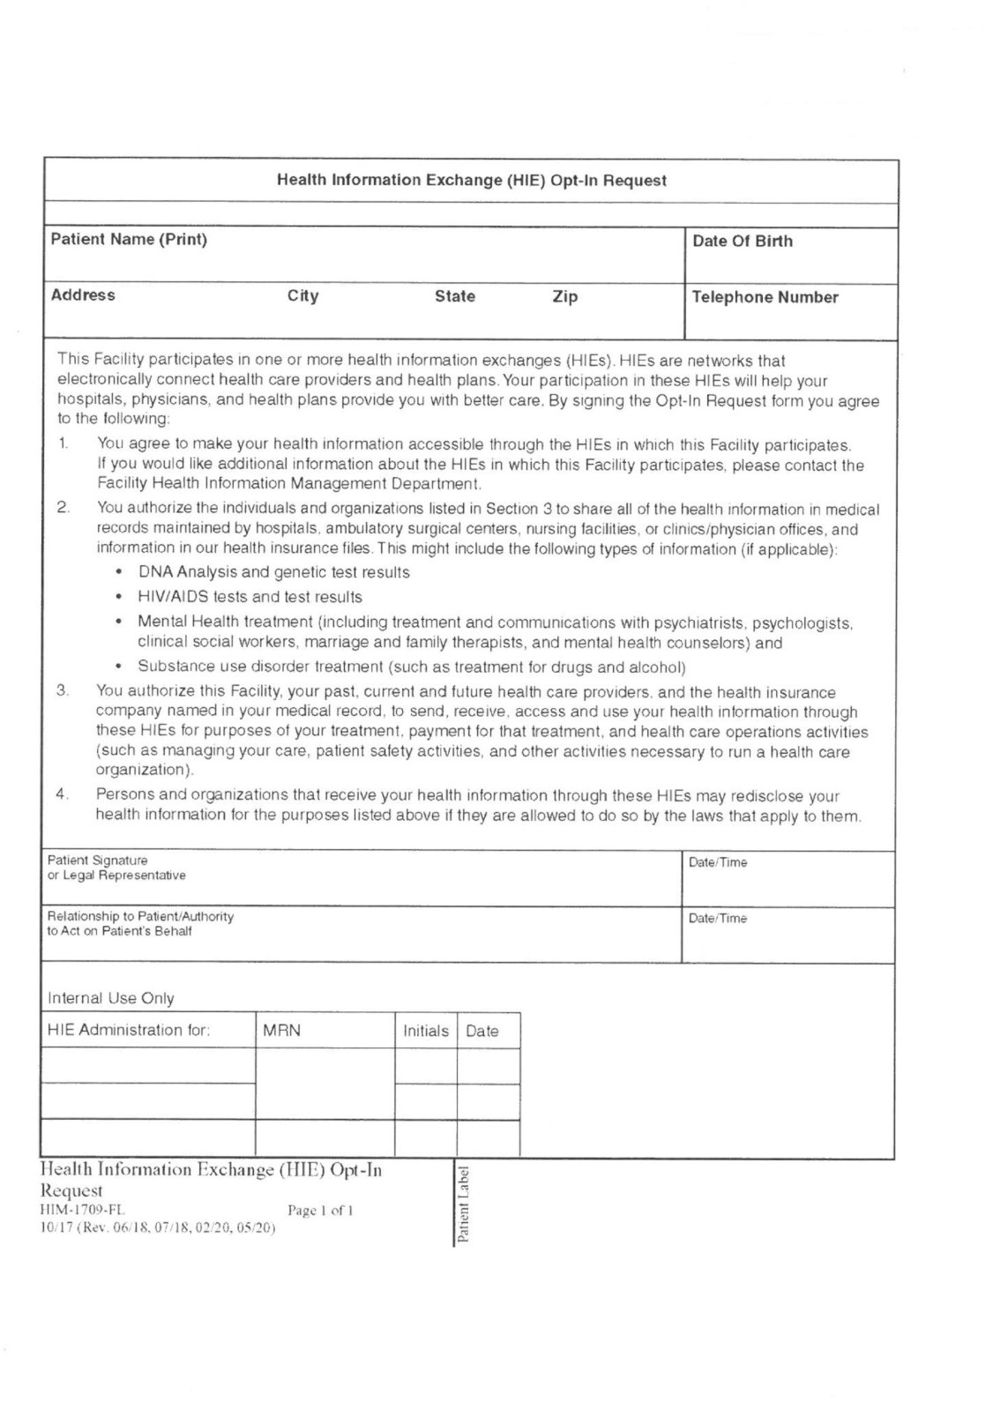

Patient Name: _________________________ DOB: ___________ Today's Date: _________________
MEDICAL PROVIDERS List providers you have seen in the past year.
Name | Specialty | Location
ALLERGIES
Drug/Food/Allergen | Reaction | Severity
MEDICATIONS
Name | Dosing Instructions | Indication

YOUR MEDICAL HISTORY Please write additional information next to positive responses.
Anemia | COPD/Emphysema | Heartburn/Reflux | Bladder Problems
Anxiety | Cancer | Herpes | Seizures
Arthritis | Heart Disease | High Blood Pressure | Skin Problems
Asthma | Dementia | High Cholesterol | Stroke/TIA
Back/Neck Problems | Depression | HIV/IIIDS | Thyroid Problems
Blood Clots | Diabetes | Kidney Disease | Tuberculosis
Blood Vessel Problems | Colon Bleeding | Liver Disease | Stomach Ulcers
Bowel Problems | Gout | Lung Disease | Use Blood Thinners
Breast Problems | Headaches | Osteoporosis | Hospitalizations
FOR FEMALE PATIENTS: | Menstrual Problems | Pregnancies | Last Menstrual Period:

Past Surgeries
Type of surgery/problem | Year | Details

Prevention History Please provide year if known.
Pap | Influenza Vaccine | Shingles Vaccine
Mammogram | HPV Vaccine | Tetanus Vaccine
Colon Cancer Screening | Pneumonia Vaccine | Covid Vaccine

Social History
Tobacco use | Never Former Current | Packs per day or week? How many years?
Vape or E-cig | Never Former Current | How much?
Smokeless Tobacco | Never Former Current | How much?
Alcohol Use | Never Former Current | How many drinks/day, week or month?
Illegal Substance Use | Never Former Current | Type? Frequency?

Marital Status | Single Married Domestic Partner Divorced/Separated Widowed
Who do you live with?
Occupation
Legal Gender | Female Male
Sexual Orientation
Gender Identity
Education
Exercise | None Occasional Regular how many times a week?
Family History
Condition | Mom | Dad | Grandparents | Siblings | Other | Condition | Mom | Dad | Grandparents | Siblings | Other
Anemia |  |  |  |  |  | Heart Disease
Bleeding disorder |  |  |  |  |  | Cholesterol
Blood Clots |  |  |  |  |  | Blood Pressure
Immune Disorder |  |  |  |  |  | Diabetes
Liver Disease |  |  |  |  |  | Kidney Disease
Thyroid Disease |  |  |  |  |  | Cancer (specify type)
Stroke |  |  |  |  |  | Depression
Dementia |  |  |  |  |  | Anxiety
Migraine |  |  |  |  |  | Substance Use
Seizures |  |  |  |  |  | Other
Osteoporosis

Patient’s Name |  |  | Date of Birth
Address City State Zip |  | Telephone Number |  |  | Email Address
I authorize the use and disclosure of health information about me as described below.
Facility Authorized to Release my Health Information:
Address City State Zip |  |  |  |  |  |  | Telephone Number
Agency or Individuals) Authorized to Receive my Health Information;
Address City State Zip |  |  |  |  |  |  | Telephone Number
Health Information that may be used/disclosed is limited to the following:
- Progress Notes | - Emergency Room Record | - Discharge Summary | - History and Physical | - Consultations
- Pathology Report | - Operative Notes | - Imaging/V-Ray Films | - X-Ray reports | - Entire Record
- Fetal Heart Monitor Strips
Other (specify) +
Sensitive Information:
- Alcohol Abuse | - Drug Abuse | - Communicable Diseases, including HIV Status
- Genetic Testing | - Psychiatric/ Behavior Diagnosis
Health Information that may be used / disclosed is limited to the following periods of healthcare:
Account Number:
Account Number:
To (date):
To (date):

From (date):
From(date):
Health Information to be released to the above-named agency / individual is to be used. disclosed for the following purpose(s):
- Treatment/ Consultation | - At request of patient | - Research | - Marketing | - Billing or Claims Payment
- At Request of Employer | - Other______________

"Health Information" identifies you (the patient) by name and includes other demographic information about you. "Health Information” may include, but is not limited to medical records, x-rays, slides, tracings, strips, etc.
I hereby discharge the releasing facility, its agents and employees from any and all liabilities, responsibilities, damages, and claims which might arise from the release of information authorized herein, including Sensitive Information as indicated above, which was compiled during my visit, encounter or hospitalization, or make copies thereof in accordance with the policies of this facility.
Protected Health Information used or disclosed pursuant to this authorization may be subjected to re-disclosure by the recipient and is no longer protected by the privacy rule. If research-related Health Information is used or disclosed for continued research purposes, an expiration date or event does not apply.
This authorization will automatically expire 60 days after the date of Signature below (except as indicated below), unless an earlier date is specified, or at the conclusion of a specified event. I understand that I have a right to revoke this authorization at any time, in writing, as stated in the Notice of Privacy Practices, except where the facility has already made disclosures in reliance upon my prior authorization.
Treatment, payment, enrollment or eligibility for benefits may not be conditioned on obtaining an authorization if the HIPAA prohibits such conditioning. If conditioning is permitted, refusal to sign the authorization may result in denial of care or coverage.
NOTICE TO RECEIVING AGENCY OR INDIVIDUAL: This information is to be treated in accordance with (HIPAA) privacy regulations.
Patients Signature  Or Legal Representative |  |  |  |  |  | Date/Time
Relationship to Patient/Authority  To Act on Patient’s Behalf | Interpreter, if utilized |  |  | Date/Time
Witness  Signature | Date/Time |  |  | Expiration Date or Event
- *Signature validated against driver's license or Signature in Medical Record. There may be a charge for copying Medical Records
- Electronic copy requested.

